Weather Analysis

Unicamp Data Science – Data Analysis Module

Hirley Dayan Lourenço da Silva  
Marcia Parmigiani

Indaiatuba, March 10th, 2018

## Data Loading

The dataset contains a series of weather measurements collected since March 2014, handled by the **Center of Meteorological and Climate Research Applied to Agriculture** - **Cepagri** at **Unicamp** - as part of the research program of agrometeorology and remote sensing applied to agriculture and ecophysiology.

# Cepagry dataset URL:  
# file <- url("https://ic.unicamp.br/~zanoni/cepagri/cepagri.csv")  
file <- "cepagri.csv"  
  
# Reading the dataset from the URL:  
cepagri <- read.table(file, header = FALSE, fill = TRUE, sep = ";",   
 colClasses="character")

The dataset contains **259706** observations and **5** features.

The data observations are composed of temperature (temperature), in centigrade (oC), wind speed (wind), in kilometer per hour (Km/h), humidity (humidity), in percentage (%), and thermal sensation (sensation), in centigrade (oC), collected every 10 minutes.

The feature names are set as follows as part of the preparation, as the source dataset does not contain the feature names:

# Feature names:  
feature.names <- c("datetime", "temperature", "wind", "humidity", "sensation")  
names(cepagri) <- feature.names

## Data Cleansing

The data is acquired from deployed sensors and errors are expected during the collection. The string [ERRO] may occur in the collected observations in case faults occur during the acquisition of the data. The table following shows a few [ERRO] occurring observations from the dataset:

|  |  |  |  |  |  |
| --- | --- | --- | --- | --- | --- |
|  | datetime | temperature | wind | humidity | sensation |
| 26491 | 12/09/2014-17:50 | [ERRO] |  |  |  |
| 26673 | 14/09/2014-00:10 | [ERRO] |  |  |  |
| 26674 | 14/09/2014-00:20 | [ERRO] |  |  |  |
| 26675 | 14/09/2014-00:30 | [ERRO] |  |  |  |

There are **2320** observations that contain the string [ERRO] that must be removed from the dataset.

The string [ERRO] might be followed by spaces and in order to facilitate the removal of those lines, sapply is used first for removing any spaces from the observation values knowing that the dataset was imported in character format.

# Removal of entry spaces  
cepagri <- as.data.frame(apply(cepagri,2,function(x)gsub('\\s+', '',x)),   
 stringsAsFactors = FALSE)

[ERRO] string can now easily be removed once the spaces have been removed from the observation values by doing:

# Replace any ERRO entry with NA value  
cepagri[cepagri=="[ERRO]"] <- NA

For a proper interpretation of the date and time values of the feature datetime, the values have to be converted into POSIXlt format:

cepagri$datetime <- as.POSIXct(cepagri$datetime, format="%d/%m/%Y-%H:%M")

Additionally, the character features can also be converted into double with:

cepagri[,-1] <- as.data.frame(sapply(cepagri[,-1], as.double))

After the cleaning, there are **0** observations that contain the string [ERRO] in the dataset.

The data period chosen for this study was from **January 1st, 2015** to **December 31rd, 2018** as follows:

# Selecting initial and final working dates:  
data.period <- c(as.POSIXct("2015-01-01 00:00:01"),   
 as.POSIXct("2018-12-31 23:59:59"))  
cepagri <- cepagri[cepagri$datetime >= min(data.period) &   
 cepagri$datetime <= max(data.period),]

The filtered dataset for the desired period contains **208274** observations and **5** features.  
Besides having features converted into the correct format, and any known incorrect strings properly replaced with NA values, the next step is to handle lines with incomplete samples.

After the removal of **0** incomplete observations, a new dataset is created with a total of **206227** observations.

## Data Analysis

The summary that follows shows a quick overview of the cleansed dataset:

|  |  |  |  |  |
| --- | --- | --- | --- | --- |
|  | temperature | wind | humidity | sensation |
| Min. | 5.10000 | 0.00000 | 5.70000 | -8.00000 |
| 1st Qu. | 18.50000 | 16.90000 | 56.70000 | 16.20000 |
| Median | 21.40000 | 24.40000 | 72.80000 | 19.80000 |
| Mean | 21.85756 | 28.17909 | 69.90768 | 19.60679 |
| 3rd Qu. | 25.40000 | 37.30000 | 85.00000 | 23.80000 |
| Max. | 37.40000 | 143.60000 | 100.00000 | 99.90000 |
|  |  |  |  |  |

The data distribution can also be evaluated by the plot that follows:

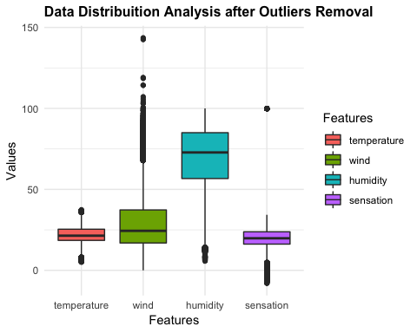

For the removal of the outliers, which are values that differ considerably from the majority of a set of data, different techniques are available. In this study, outlier removal is performed using the *capping* technique, as described in [4], by replacing values outside the $1.5*IQR$ limits, with the lower limit replaced by the **5th** percentile and the bigger limit replaced by the **95th** percentile.

The quantiles are calculated as follows:

cepagri.quantiles <-   
 as.data.frame(sapply(cepagri[,-1],   
 function(x){quantile(x, c(0.05,0.25,0.75,0.95))}))

The lower and upper limits are calculated by the equations:

Once the limits are calculated, outliers below **5th** percentile and above the **95th** percentile are replaced by both ***Lower*** and ***Upper*** limits, respectively, with the algorithm:

# Replace outliers using capping method, by replacing values below 5th percentile   
# and above 95th percentile by both lower and upper limits, respectively, where:  
# lower = Q1 - 1.5*IQR  
# upper = Q1 - 1.5*IQR  
for(n in names(cepagri[,-1])){  
 cepagri[!is.na(cepagri[, n]) &   
 cepagri[, n] < cepagri.limits["lower", n], n] <-   
 cepagri.quantiles["5%", n]  
 cepagri[!is.na(cepagri[, n]) &   
 cepagri[, n] > cepagri.limits["upper", n], n] <-   
 cepagri.quantiles["95%", n]  
}

The summary that follows shows a quick overview of the prepared dataset, after the removal of the outliers:

|  |  |  |  |  |
| --- | --- | --- | --- | --- |
|  | temperature | wind | humidity | sensation |
| Min. | 8.20000 | 0.00000 | 14.30000 | 4.80000 |
| 1st Qu. | 18.50000 | 16.90000 | 56.70000 | 16.20000 |
| Median | 21.40000 | 24.40000 | 72.80000 | 19.80000 |
| Mean | 21.86566 | 27.93708 | 69.92965 | 19.72076 |
| 3rd Qu. | 25.40000 | 37.30000 | 85.00000 | 23.80000 |
| Max. | 35.70000 | 67.80000 | 100.00000 | 34.30000 |
|  |  |  |  |  |

Additionally, the plot that follows brings another perspective for the data distribution:

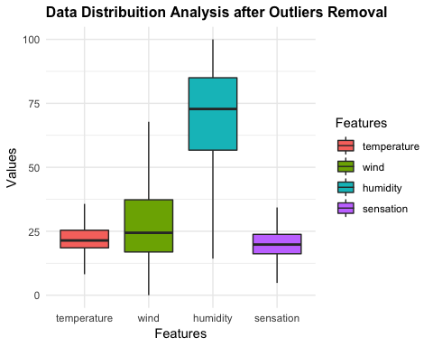

Duplicated observation values may happen and must be handled accordingly. The automatic removal of duplicates can only be done for adjacent observations as it is not a natural weather behavior to stand still all its indicators for a length of time.

The following table shows adjacent occurrences with the same measurement values:

|  |  |  |  |  |  |
| --- | --- | --- | --- | --- | --- |
|  | datetime | temperature | wind | humidity | sensation |
| 42130 | 2015-01-01 07:50:00 | 23.4 | 16.1 | 88.6 | 22.3 |
| 42131 | 2015-01-01 08:00:00 | 23.4 | 16.1 | 88.6 | 22.3 |

After the removal of **91** duplicated observations, a new dataset is created containing **206136** observations.

## Meteorological Analysis

The following graph shows the measured temperature and the temperature sensation for the period from 2015 to 2018:

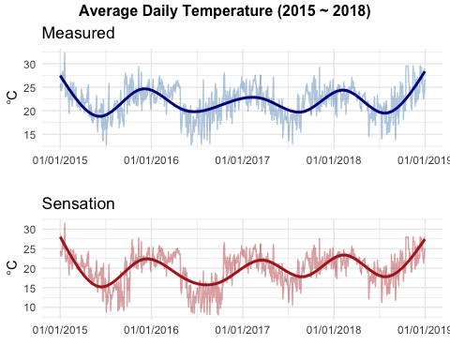

The following graph shows the measured temperature, humidity and wind speed for the period from 2015 to 2018:

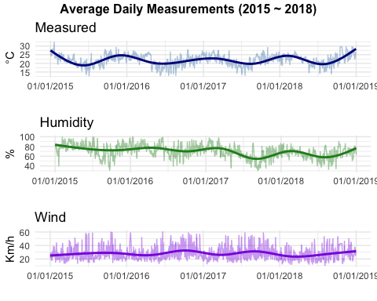

The following graph matrix brings a cross analysis overview of all sensors, showing how they related to each other.

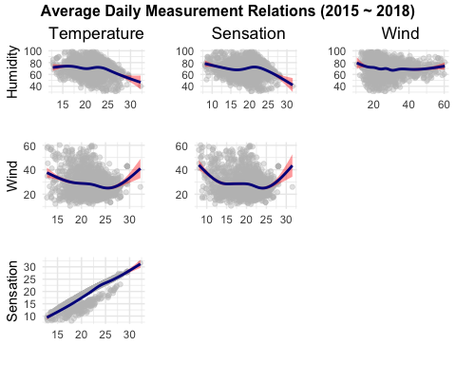

The following graph shows the daily temperature distribution between 2015 and 2018. As revealed by the graph, the temperature oscillated around the same range in the period, without presenting significant variations.

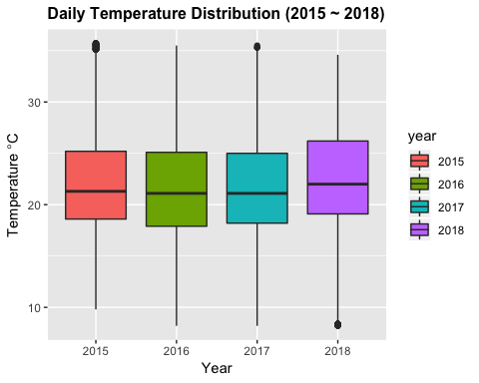

The next graph shows the relative humidity in 2018. According to the Cepagri classification indicator (CGE) [5], the humidity level below 30% is not good for health, which is indicated in the graph by the vertical red line.

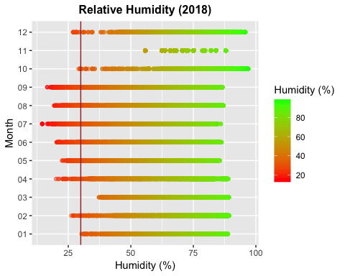

## References

[1] De Jonge, E., & Van Der Loo, M. (2013). An introduction to data cleaning with R. Retrieved from www.cbs.nl/information

[2] Wickham, H. (2014). Tidy Data. Journal of Statistical Software, 59(10). <http://doi.org/10.18637/jss.v059.i10>

[3] Beck, C. (2012). Handling date-times in R. Retrieved from <http://biostat.mc.vanderbilt.edu/wiki/pub/Main/ColeBeck/datestimes.pdf>

[4] Outlier detection and treatment with R | R-bloggers. (n.d.). Retrieved March 8, 2019, from <https://www.r-bloggers.com/outlier-detection-and-treatment-with-r>

[5] Umidade Relativa do Ar - CGE. (n.d.). Retrieved March 9, 2019, from <https://www.cgesp.org/v3/umidade-relativa-do-ar.jsp>